ORGANIZATIONAL STATEMENT

Founded in 1977, Childsplay is a nationally and internationally respected theatre company based in Tempe that performs for children and families in Arizona and beyond. Childsplay fervently believes that young people deserve to experience theatre of the highest artistic quality. This standard of excellence has shaped the organization for more than three decades. More than 200,000 children, teachers, and families experience a Childsplay performance each year.

Mission: To create theatre so strikingly original in form, content or both that it instills in young people an enduring awe, love and respect for the medium, thus preserving imagination and wonder, those hallmarks of childhood that are the key to the future

Childsplay serves the Arizona community through the following programs:

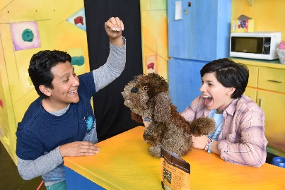
School Touring
Childsplay’s School Touring Program forms the core of our operations, presenting nearly 300 performances for 100,000 children annually. This program provides the organization the opportunity for the widest reach, bringing professional theatre productions to schools across the state that would not be able to travel to the theatre due to financial and geographical limitations.

Field Trips
Alongside the success of in-school performances, Childsplay believes the experience of going to the theatre to see a play is invaluable for children. Field trip performances take place at the Tempe Center for the Arts, and reach nearly 60,000 children each year.

Public Performances
Childsplay performs a full season of professional productions, including adaptations of beloved children’s books and original plays about relevant social issues for families at the Tempe Center for the Arts. The Benjamin Fund provides free tickets to families in need, ensuring that price is not a barrier to family participation in the arts.

Education Outreach
Childsplay’s Outreach Residency programs for schools meet the needs of Arizona schools by integrating kinesthetic learning into curriculum. Professional teaching artists work with students and teachers to integrate the arts into all subject areas, working with more than 5,000 students in dozens of Arizona classrooms each year.

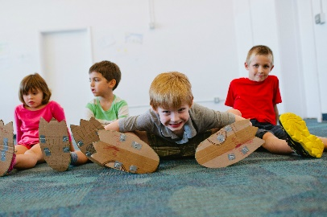
Academy
Outside of the school day, the Childsplay Academy provides theatre training for children interested in acting. More than 1,500 children participate in these programs each year, developing their skills and performers and collaborators. This program has grown dramatically since its inception, with a range of programs from recreational drama classes for preschool students to a multi-leveled conservatory program for older children.

