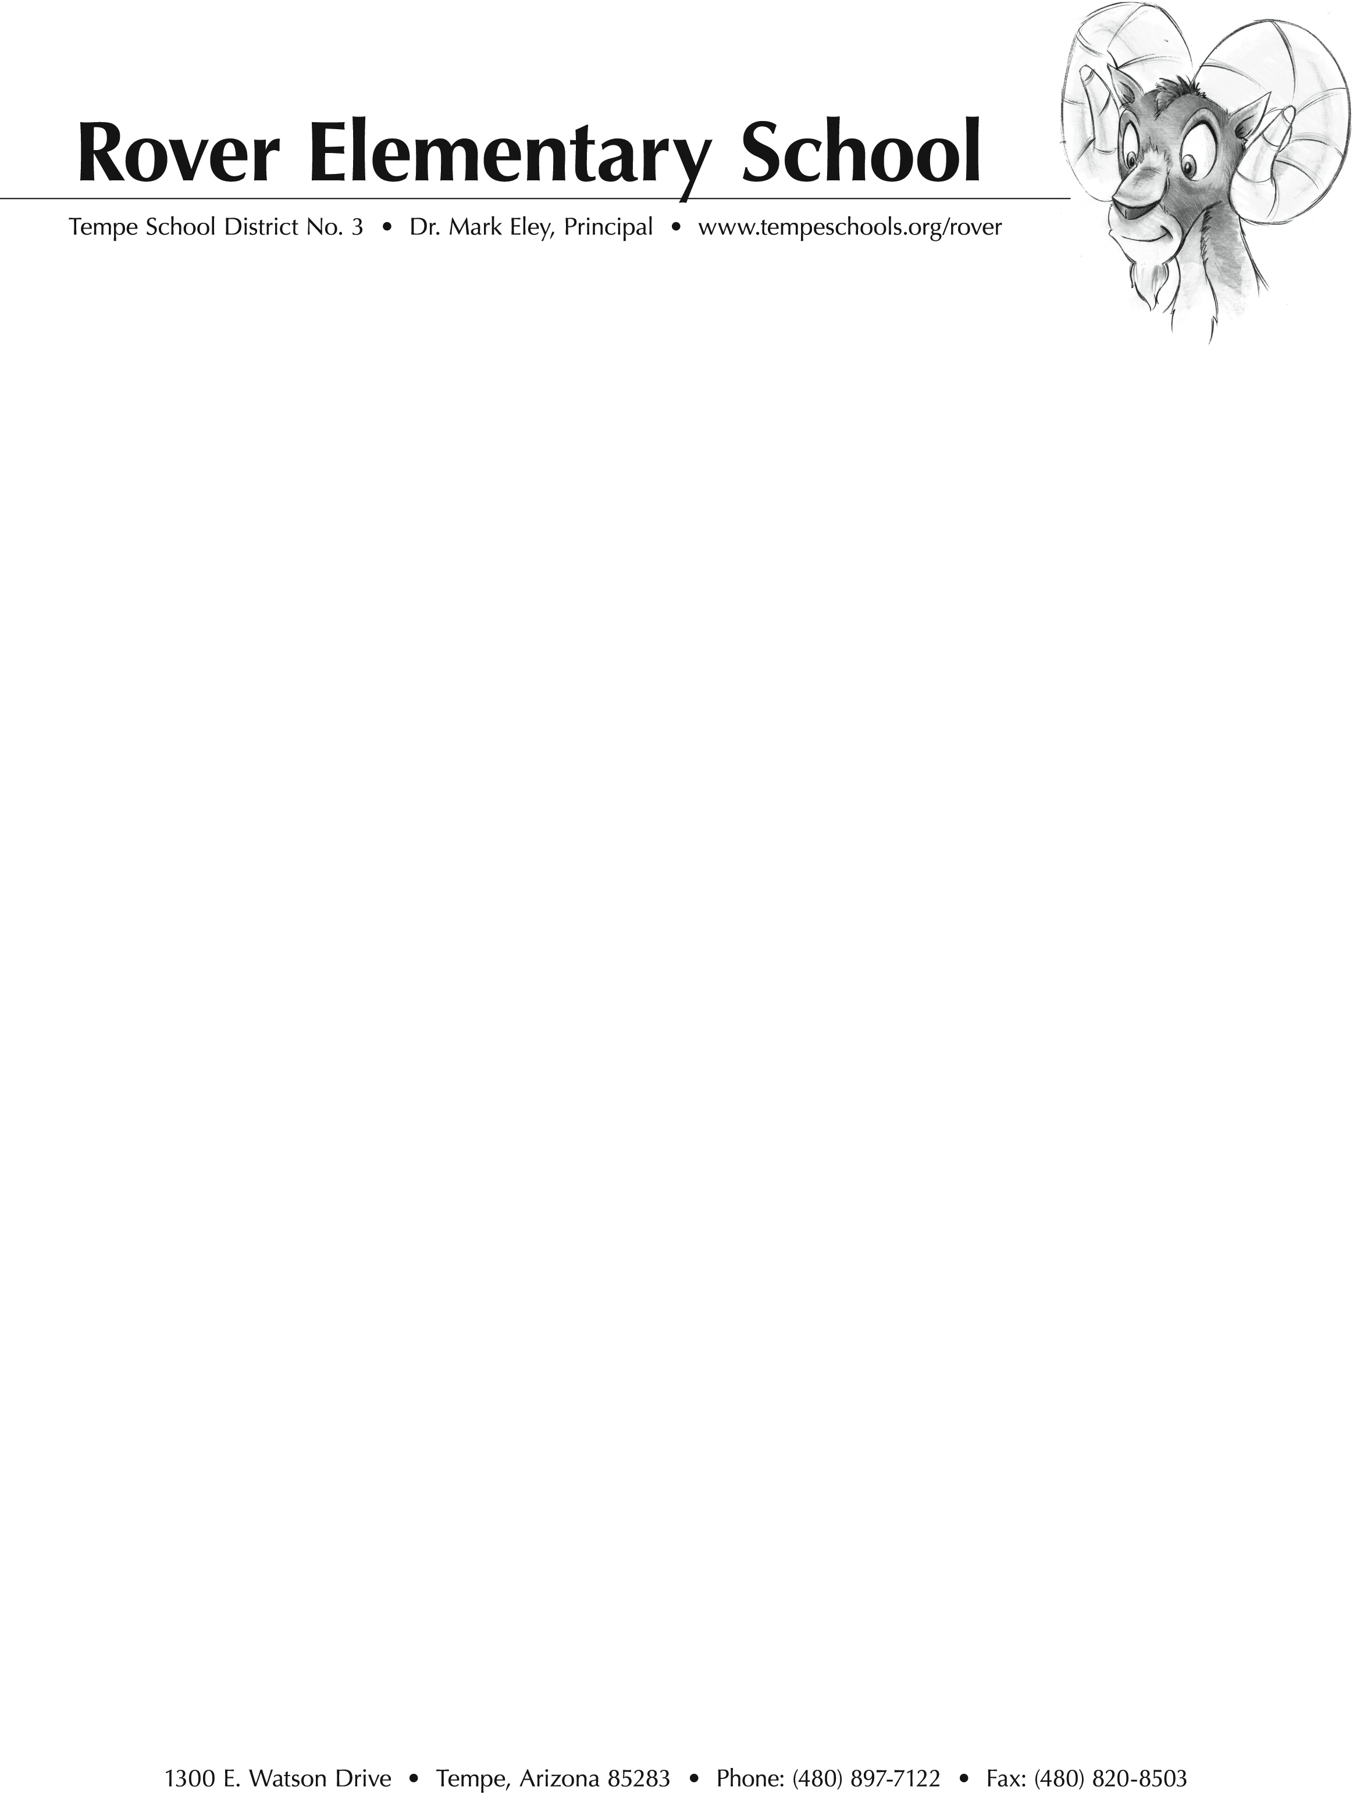
To: Arnold Mejia
From: Donna Raketich and Carol Harper
Subject: Tempe Diablos Grant

Rover is an elementary school in the Tempe School District. Our mission is inspiring every child and every adult to be excelling learners, empowered individuals, responsible citizens, and effective contributors every day. This year we are striving to become an Innovation school that empowers students with Twenty First Century learning skills. In order to reach this goal, we would like our students to have technology available to them on a one to one basis. Our enrollment is 489 students and last year with the help from Tempe Diablos, Fiesta Bowl Charities and our PTA, we were able to purchase seventy two chromebooks. Currently our fifth grade is one to one with computers but, we would like to have all first through fifth graders to have their own chromebook. At this time, first through fourth grade has two students to one computer.

Technology is an integral part of the learning and instruction at Rover School and is infused into all subject areas. The teachers at Rover School are committed to Project Based Learning. The students use the computer for research, gathering information, taking notes, creating a presentation and sharing their findings with others. Other computer based projects that enhance learning are
--using Flipgrid to respond to literature
--making book trailers (during library class) to report on books
--creating a student led yearbook
--completing thinking maps using Wixie
--working on Freckle to enhance phonics and comprehension skills and several math skills
--creating a hyperdoc to explain and present learning (using animation)
--Readworks to support reading comprehension
--Art hub to inspire creativity
--Podcast as a Literacy Station to summarize stories
--Google classroom to support all subject areas
--Morning Announcements that are created by students
--Weebly to create websites

The student population at Rover School is a mixture of students from the neighborhood and students whose parents choose the school through open enrollment. It is economically and culturally diverse. We believe that allowing students equitable access to technology increases both student engagement and academic skills in all content areas. Your support with this project would be greatly appreciated!

Additional Required Materials

17/18 Donations
- Tempe Diablos contributed a $5,000.00 grant
- Fiesta Bowl Charities contributed a $10,000.00 grant
- Rover PTA contributed a $5,000.00 grant

Annual Operating Budget
- Please view the following link;
https://www.tempeschools.org/our-district/budget

School Board Members
- Rochelle Wells-President
- Monica Trejo
- Teresa Devine
- Jim Lemmon
- Patrick Morales

