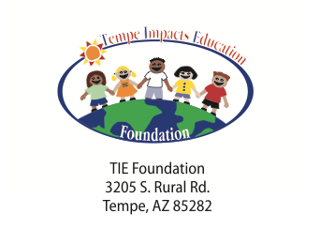
TIE FOUNDATION
TEMPE IMPACTS EDUCATION FOUNDATION
A group of caring volunteer ambassadors who are a conduit to broker resources from the greater community to support Tempe Elementary School District's children, families and educators to achieve successful lifelong educational goals.
The Tempe Impact Education Foundation was established in 1990 to provide extraordinary opportunities to the children of the Tempe. Although children receive a strong basic education in Tempe, Arizona's funding formula is one of the lowest. Consequently, our children are deprived of experiences children in other states receive as a matter of course.
The Tempe Impact Education Foundation was established to make up for some of those deprivations. Our efforts will take time and perseverance. Hundreds of citizens in Tempe will become the benefactors. Thousands of children will benefit. The goal of the Tempe Impact Education Foundation is to enrich and enhance the District's commitment to excellence.
We will use the grant money from the Tempe Diablos to continue support of the underserved students in the Tempe School District in all of the target areas described
Assistance for Children in Need
Each year 35,000 pounds of rice and beans are delivered to Tempe Elementary Schools. The Rice and Beans are distributed to thousands of families to help them meet their nutritional needs. TIE contributes to this effort.
- Connecting with Kids – A “store” stocked by TIE and operated by the district’s social workers -school supplies, clothing, shoes, hygiene products, to enable children to attend school with confidence and pride.
- Summer School Scholarships – Allows children to attend Summer Enrichment School.
- Math, Science and Music Awards – To encourage academic excellence, outstanding students in all schools are recognized for their scholastic accomplishments.
- Weekend Backpack program-Feeding kids on the weekend who eat free lunch during the week.
- Health care needs for students-Pay for glasses, doctor visits and prescriptions.
- Musical Instruments – Provide band or orchestra instruments.
Support for Quality Classrooms-
• Scholarships for School Staff
• Grants for classroom projects
TIE has the ongoing responsibility to support the underserved students in the Tempe Elementary School District. Each year the needs increase. Seventy-five percent of the 11,500 students in the Tempe Elementary School District qualify for free lunch program. This statistic indicates an ever-increasing number of students who need support with basic clothing and medical needs. The support of the TIE Foundation to assure critical services and support is even more critical.

